**Exercise 10: What Was That?**

1. Memorize all the escape sequences by putting them on flash cards.

**Ok.**

1. Use ''' (triple-single-quote) instead. Can you see why you might use that instead of """?

**If using ‘’’ single quotes, we got only the strings not variable value.**

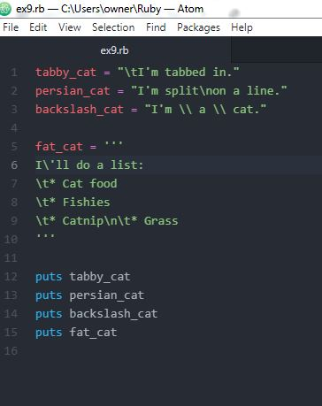

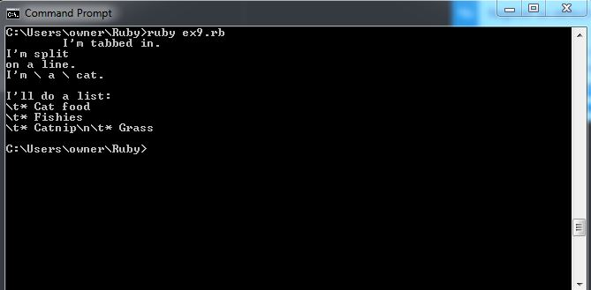

1. Combine escape sequences and format strings to create a more complex format.

